# Project Background

## Motivation

When discussing the topic regarding what we should base our project around, we found ourselves quickly struggling to find ideas that would meet our common interests both inside and outside of IT. Because of our struggles, we decided to not over complicate our project.

This revelation allowed us to narrow down our project into a single, achievable goal; one in which we were all satisfied with. None of us had too much experience with web development so we found building a website to be an interesting challenge as we approached it as both a learning opportunity, as well as an opportunity to create something we were all passionate about.

Finally, we decided to base the website around the concept of pizza, as we established quickly that pizza websites are somewhat of a staple for the internet in its current state, and we would have a lot of research material to base our project on. We were also excited by the idea to build a website about something many have come to take for granted over the years; food.

## People

**1. Benjamin Kiprotich,** [**s3735277@student.rmit.edu.au**](mailto:s3735277@student.rmit.edu.au)

**Interest and Skills:**

I became interested in IT while I was still a kid when I first used my dad's Motorola razr and I was interested in technology and how the software and hardware interact. I am good in art and I am interested in animations but in computer I am genuinely interested in the programming part, I could do game programming or cloud computing and later major in cyber security.

**Individually Assigned Role:**

My assigned role is one of the coders alongside Harris. Together, we work on coding the pages based on the mock-ups that we designed earlier. We focus on building up the user interface and building the Minimal Viable Features that we pre-established, for which we have divided up between ourselves.

**2. Ian Romito Descham,** [**s3665571@student.rmit.edu.au**](mailto:s3665571@student.rmit.edu.au)

**Interest and Skills:**

I come from a developing country, where the field of Information Technology (IT) is not focused/delved on strongly. As such, my background in IT is quite weak in term of knowledge. I do, however, tend to try my hands at the field whenever it is convenient for me to do so. For instance, I did enrol into a robotic class and electro class at primary and secondary school. From these, I get some basic knowledge in IT, such as programming and hardware concepts. I believe I am a little good at programming. I might also have a little skill in writing, as I did get several commendations on my writing skill, which could be helpful in writing reports.

**Individually Assigned Role:**

As for my role in the project, I am the dedicated researcher and write up the documentations regarding the reports. I conduct all the research needed for the developers and compile it into an easy to read document for the developers. This would include looking at competitors websites to view the overall average price for each pizza, which I then document and send off to Harris and Ben.

**3. Harris Charalambous,** [**s3742332@student.rmit.edu.au**](mailto:s3742332@student.rmit.edu.au)

**Interest and Skills:**

I have always had an interest in IT based skills; this includes concepts about Java development and web development. While Java is not very applicable to this project, I am able to demonstrate and extend my knowledge in the field of web development, and as such, improve my overall IT based skills. Furthermore, I have always had a passion for pizza, so the merger of IT and pizza is a combination that interests me greatly.

**Individually Assigned Role:**

I am one of the dedicated coders for this website, alongside Ben. With Ben, we work on bring our mock-ups to life, with working functionality based on the Minimal Viable Features we established earlier on in our timeline. I have been working hard on creating the homepage, which we are using as a template to build off of for the remaining pages and/ or features.

## Aim and Goals

**Aim**

We want to create a simple and efficient pizza website that has an aspect of “gamification”to it, meaning to have some features act almost as a game, adding an entertainment value to the site. Above all else however, we value speed in the site, and are actively trying to make it the fastest ordering experience available for customers. It will allow customers to add pizzas to their order via a single click, which is common amongst competitors. However, where the project will differ from competitors, and greatly increase the ordering time, will be the ability to duplicate customised and self built pizzas, something which is not commonly allowed amongst other websites. While the main development focus is in making the website responsive amonsts computers, it is the aim to also make the site mobile responsive post launch, to make the site accessible from any device.

**Goals**

*Add Pizzas to Cart:* While seeming simple, the goal of adding pizzas to a cart is absolutely essential for the site. It will track which pizzas have been customised, which have been built from scratch, and which have been selected from the menu. From here, the pricing can be calculated and displayed to the user. The goal of this is so that all of this would happen in the background without the user having to interact, creating a better user experience, as well as speeding along the ordering process as the user is not stopped having to deal with obnoxious cart difficulties.

*Order as Quickly as Possible:* The main priority with this project is efficiency and speed. Therefore, this goal has been kept in mind when designing and implementing all functionality. Anything that can be reduced to a lesser amount of clicks for the user has been, as evident through the user being able to duplicate customised pizzas, as opposed to having to re customize the pizza every time they wanted to add another.

*Show Current Promotions:* Through evaluation of competitors, we determined that specials are essential when ordering pizzas online. As such, this goal is to make sure the customer is always informed of the latest and current promotion currently offered by the pizza store. This will be completed by a pop up that opens automatically when the user first enters the page. As it is only a single click to close it, we believed this goal did not clash with our goal to make ordering as quickly as possible.

*Track Order in Collapsible Sidebar:* This goal is to have the website track the order and display it for the customer so that they are not required to remember what is in the order they are currently placing. This would be collapsible so that the user can remove it if it is unnecessary, and can be brought back up if they choose to want it afterwards. This is built entirely for the customer so that their ordering experience is as smooth and effortless as possible.

*Customise and Build Pizzas:* This is to have users be able to customise and build pizzas to their liking. The main goal for this is to improve the customer experience overall as the customer would feel more involved and more in control over their food and order.

## Scope

From an evaluation of our project, we have identified key features that are essential to a working build or prototype. They are listed in order of importance, with the first feature being the utmost important, while the last feature not being as significant as the rest, but still essential to the build of project.

|  |  |  |
| --- | --- | --- |
| **Project Goals** | **Deliverables / Outcomes** | |
|  | Design | Description |
| Basic Menu | Layout | This involves making sure the site is symmetrical and aesthetically appealing. |
| Collapsible Tabs | This makes sure that the menu is divided into working collapsable tabs so that the user can filter and only see portions of the menu that are relevant to them. |
| Correct Information | This is regarding the specific pizzas themselves, and making sure that all ingredients listed are accurate, descriptions are clear, and nothing we are presenting is vague or misleading. |
| Sidebar | This involves having a working sidebar that opens when items are added to the order and closes when the user decides. It also involves making sure it presents the user’s order clearly and accurately. |
| Place Order | User can Input Payment Details | Fields for details of customer payments will be available for users to enter their payment details, or select ‘’pay by cash’’ option. |
| Copy of Order is Sent to Restaurant | An order summary is sent to the restaurant via email for them to make the order. |
| Copy of Order is Sent to User | An order summary is sent to the user’s email so that they can review their order and confirm they received the correct pizzas. |
| Customise/ Build Pizza | Display Ingredient Lists | An ingredients list on what currently available/ already on the pizza will be displayed in a list-like view. |
| Remove Items from Pizza | Users will be able to remove items that are already placed on the pizza, either by the premade default listing or by them adding the ingredient on. |
| Add Items to Pizza | Users are able to add ingredients to pre-existing pizzas, or pizzas they are building. |

The following are features we believe to be improvements to the site, but are not considered essential to the working build and overall scope of the website and project. Presented in no particular order.

|  |  |  |
| --- | --- | --- |
| **Project Goals** | **Deliverables / Outcomes** | |
|  | Design | Description |
| User Accounts | Add Username and Password | Users will be able to create accounts that remember order details by having them save into a database. |
|  | Remember Orders | When logged in, users will be able to see previous orders and reorder exact orders. It will also save their details such as payment information and address. |
| Pop-Up Promotions | Display Promotions | The promotion pop-up will appear when the user opens up the site. |
| Rating System | User can Rate Pizzas | Users will be able to rate pizzas out of 5 stars. |
| Average Rating of Pizza will be Calculated | The average review of the pizzas will be displayed alongside the pizza. |

# Project Progress

The decision to make a pizza based website was relatively quick and unanimous. While we did have some hesitation and reluctance, due to us meeting each other and having to decide the project entirely on the same day, we were able to quickly overcome that stalemate and draft a plan to implement. We also distinguished that amongst ourselves, we had the beginning skill sets to take create something that we could be proud of, as we all had differing skills and abilities that meant we could learn off each other and give our expertise to the project.

Creating the project timeline was quite simple, as we were able to come up with it within a single meeting. We found it to be quite fair and steady, so after all troubleshooting was set, we assigned everyone research and development roles for which we could adhere to.

However, this timeline was rarely able to be followed; this is due to the unfortunate unenrollment unenrollment of one group member, causing the workload we had planned between four people to then be divided into three. Here, we made the pivotal decision to attempt to continue with the established timeline. This made our time severely limited and, in hindsight, a reevaluation of the scope would have been necessary. One instance of a feature impacted by the reduced time is the “”Customise Pizza” segment of the project we made a Minimal Viable Feature. The feature involved several hand drawn images that we had planned to integrate, which when our group member left, caused issues as none of the remaining members had the artistic ability to draw out the required elements. This caused hardship in the project as we were limited in the ability to create the required elements.

Despite the difficulties and hardships we encountered through losing a member and reallocating the workloads, we were still able to create major of portions of the expected outcomes. For instance, research and creation of the menu and template went away fantastically, with us being able to create multiple designs and layouts, and even experiment with multiple colour palettes. Implementation of the expected sidebar took longer than originally allocated, however it eventually became fully implemented and functional.

If we had a greater amount of time for the development, we would work implementing the extended viable features, such as the map tracker. While we do not believe this to be overly difficult, due to the loss of the member, we are struggling to incorporate the entirety of minimal features.

# 

# Outcomes to Date

**Prototypes (Mock-Ups)**

Presented below are two design mockups created to demonstrate a generalised layout of how the website would look (*Figure 1*). Also pictured is the expected implementation of the sidebar and how the functionality would operate (*Figure 2*).

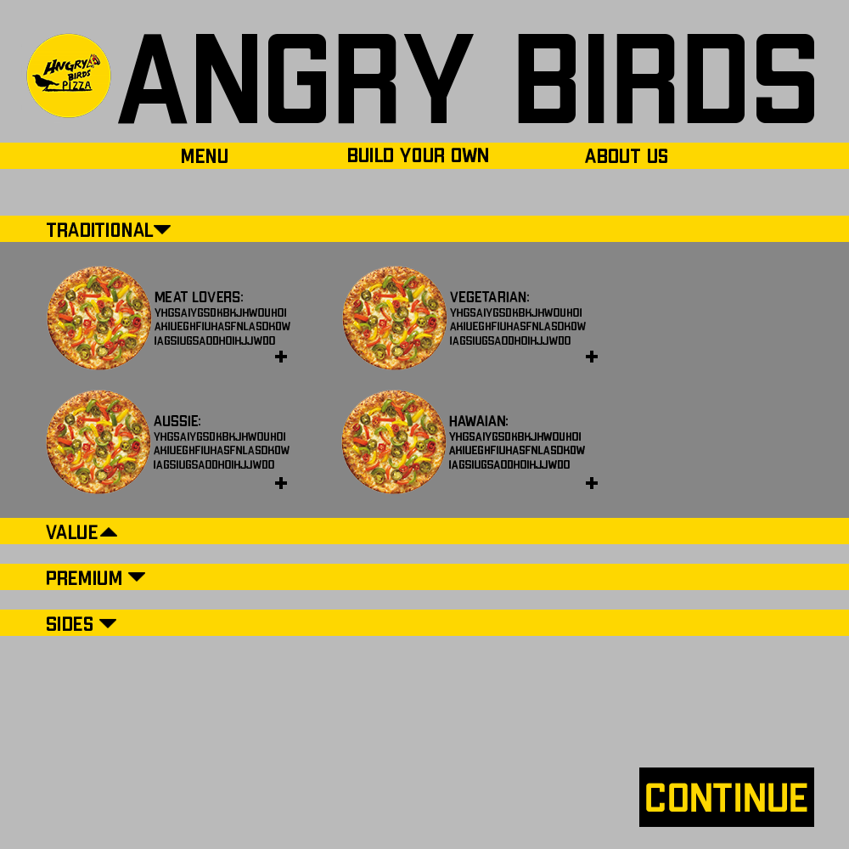

*Figure 1*

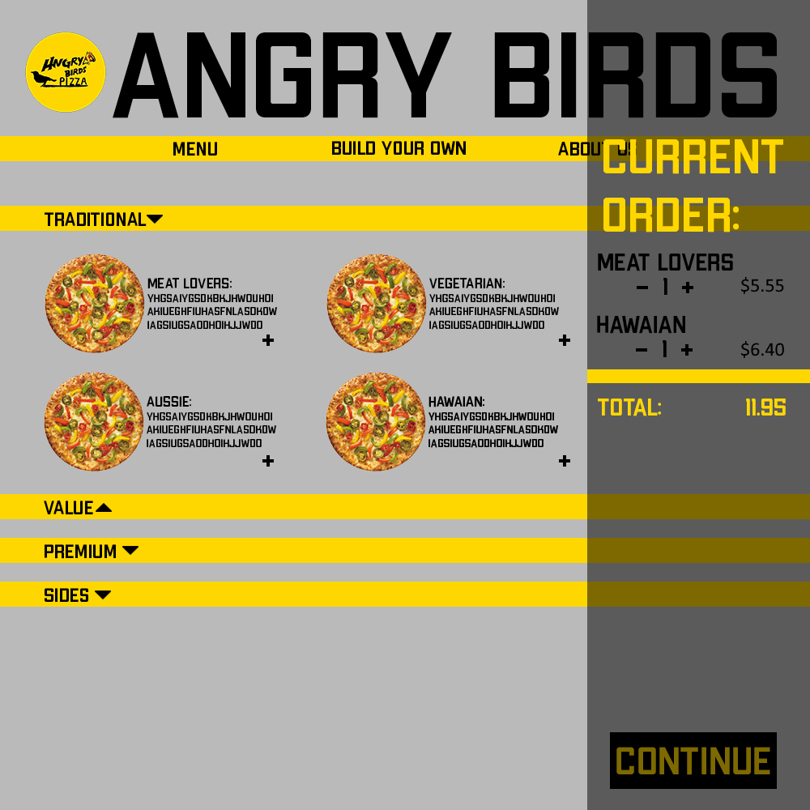

*Figure 2*

**Front End Interface (PC)**

Pictured below in *Figure 3* is the functional and working prototype of the user interface designed in the mockups. The bars are collapsible as expected and the sidebar is operational, although at this instance is not very aesthetically pleasing (*Figure 4*).

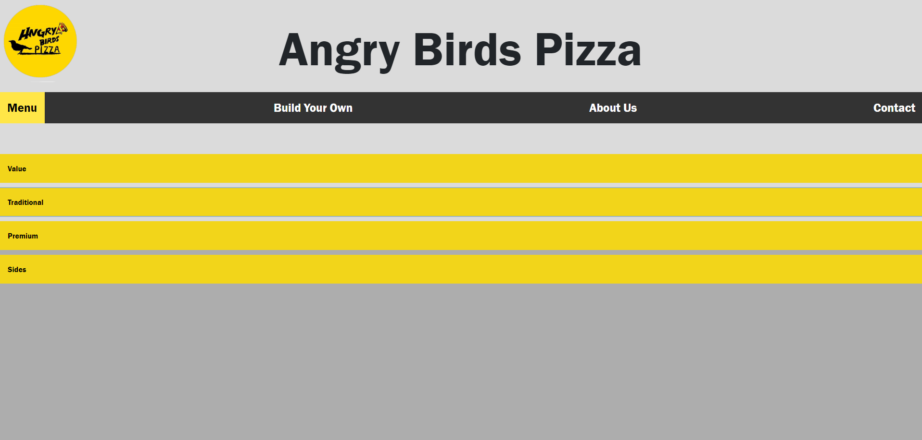

*Figure 3*

*Figure 4*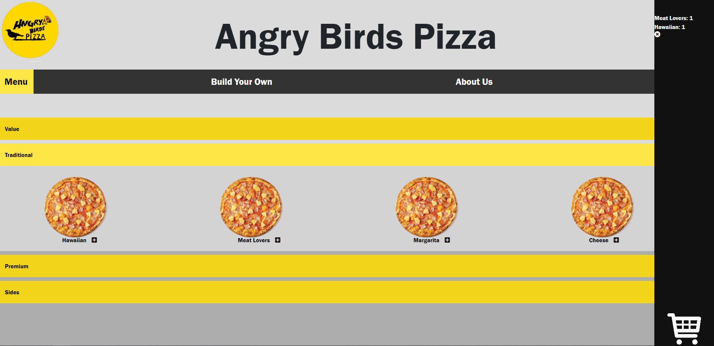

**Alternative Designs**

While the mockups were useful in showing us a working layout, we still decided to experiment with colours, fonts and orientations. Pictured in *Figure 5* and *Figure 6* are some alternative designs that we experimented with.

*Figure 5*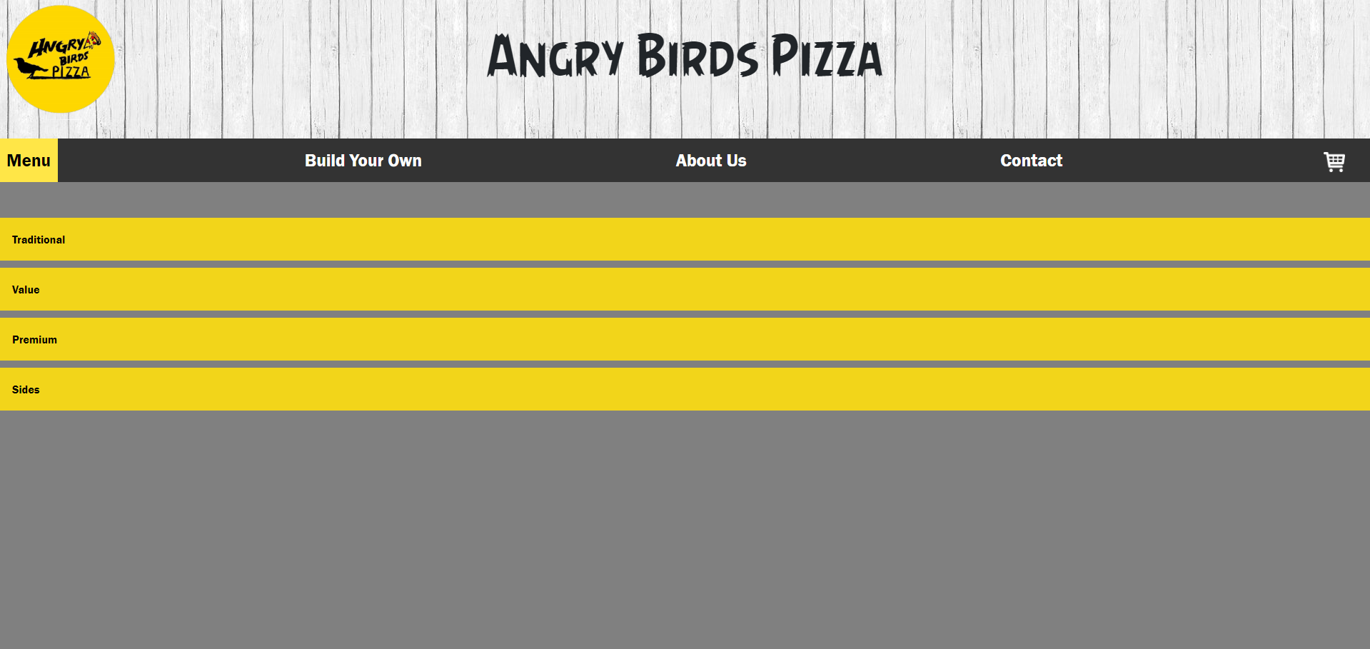

*Figure 6*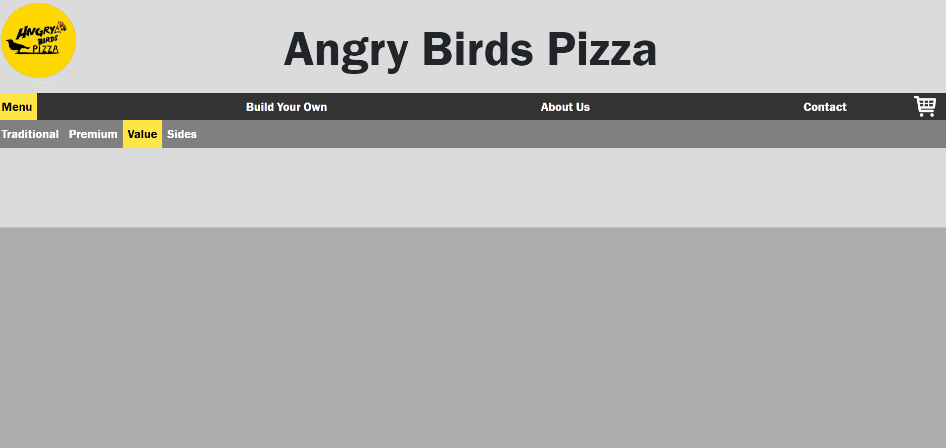

**Back End (JavaScript, CSS, HTML)**

*Figure 7, Figure 8, Figure 9* show the HTML, CSS and Javascript code respectively.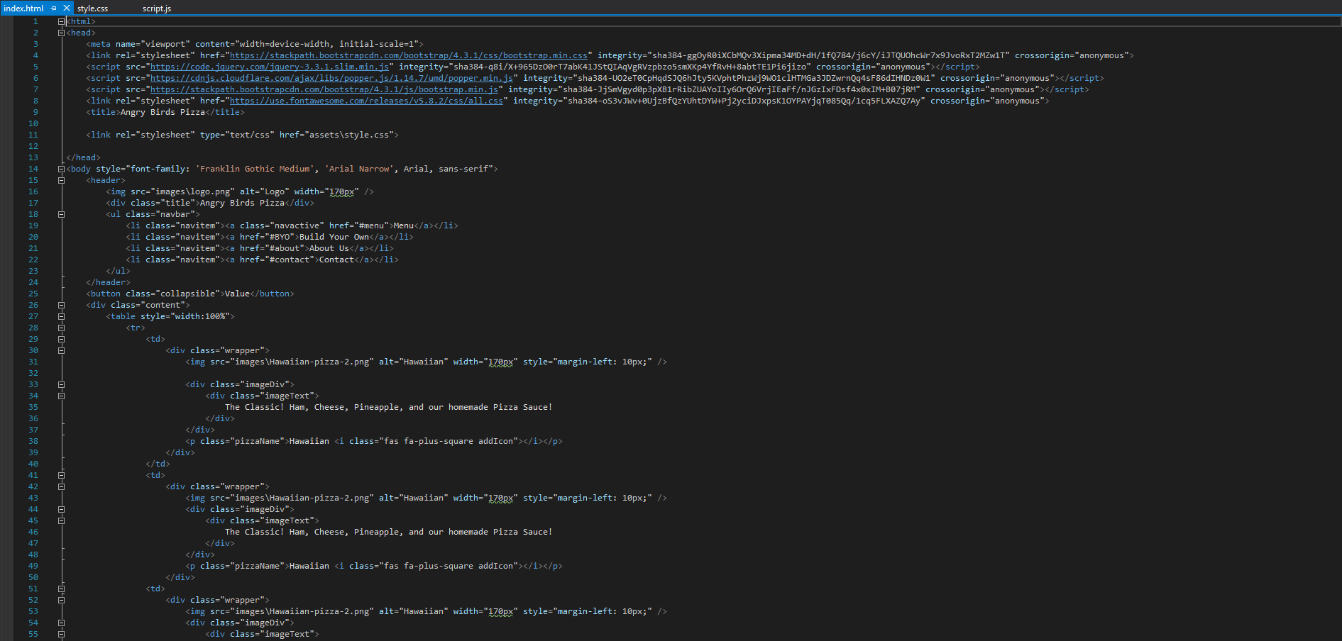

*Figure 7*

*Figure 8*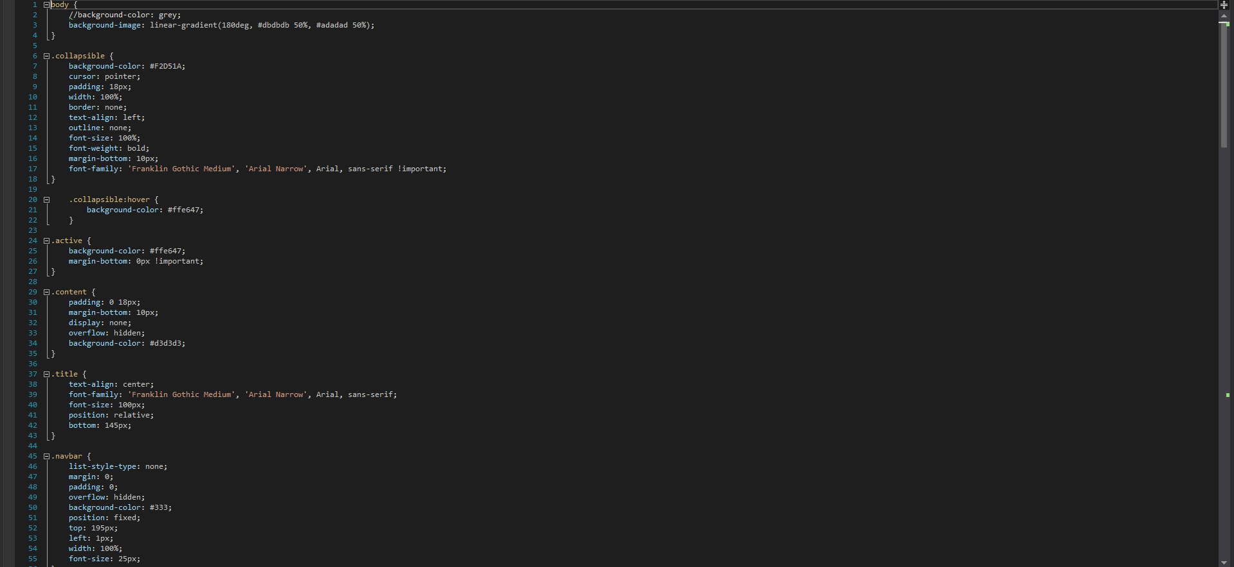

*Figure 9*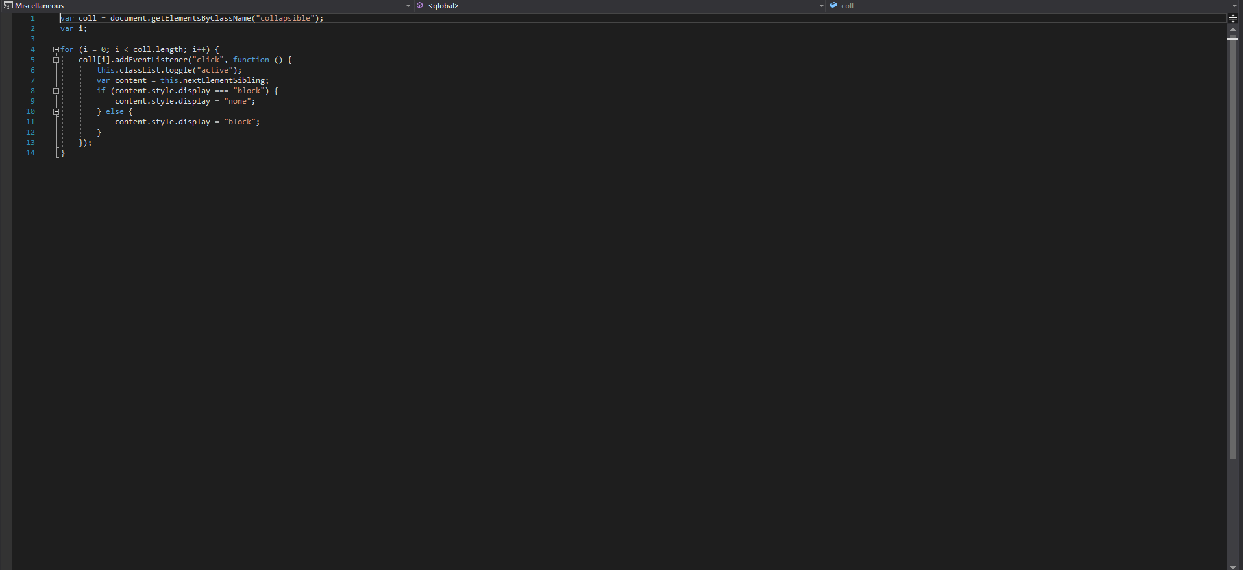

Scope Creep

Due to the unfortunate loss of one group member, we suffered quite a large contraction in scope. Segments that would have required drawn assets or custom assets had to be reworked entirely, such as the customise pizza segment which would have had custom assets overlay on top of each other to simulate the pizza design and ingredients. Without the assets though, we were forced to reevaluate the feature and make something significantly less exerting of the developers.

# Progress

|  |  |  |  |
| --- | --- | --- | --- |
| **Title** | **Planned Start** | **Planned Due** | **Finish Date** |
| Week 3 | | | |
| [Describe the project (website) description and main features](https://trello.com/c/WI2vmM1i) | 18/3 | 24/3 | 24/3 |
| [Describe team’s workspace and communication method(s)](https://trello.com/c/SLdXOH2O) | 18/3 | 24/3 | 24/3 |
| [Make an overall plan for the website’s development](https://trello.com/c/imB79zTL) | 18/3 | 24/3 | 24/3 |
| [Describe future possible features](https://trello.com/c/fl3VdXnb) | 18/3 | 24/3 | 24/3 |
| Week 4 | | | |
| [Finalise the project (website) description and main features](https://trello.com/c/hGJMBqi2) | 25/3 | 29/3 | 29/3 |
| [Finalise team’s workspace and communication method(s)](https://trello.com/c/Ouk8SVmf) | 25/3 | 29/3 | 29/3 |
| [Finalise overall plan for the website’s development](https://trello.com/c/erspmpeu) | 25/3 | 29/3 | 29/3 |
| [Documentation revision and formatting](https://trello.com/c/mXOhUjdj) | 29/4 | 31/3 | 29/3 |
| Week 5 | | | |
| [Research on minimal viable feature #1 (Add to Cart) – Design](https://trello.com/c/YWnLn8lA) | 1/4 | 7/4 | 7/4 |
| [Research on minimal viable feature #1 (add to cart) – Coding](https://trello.com/c/KZOa0akn) | 1/4 | 7/4 | 7/4 |
| [Research on minimal viable feature #2 (Customise Pizza) – Design](https://trello.com/c/IgB8RR1C) | 1/4 | 7/4 | 7/4 |
| [Research on minimal viable feature #2 (Customise Pizza) – Coding](https://trello.com/c/lKmOjbGe) | 1/4 | 7/4 | 7/4 |
| Week 6 | | | |
| [Research on minimal viable feature #3 (Place Order) – Design](https://trello.com/c/0ue0RF3g) | 8/4 | 14/4 | 14/4 |
| [Research on minimal viable feature #3 (Place Order) – Coding](https://trello.com/c/s9hiW4eX) | 8/4 | 14/4 | 14/4 |
| [Research on minimal viable feature #4 (Set Quantity) – Design](https://trello.com/c/rzLeCUjj) | 8/4 | 14/4 | 14/4 |
| [Research on minimal viable feature #4 (Set Quantity) – Coding](https://trello.com/c/d5f5VmGV) | 8/4 | 14/4 | 14/4 |
| Week 7 | | | |
| [Research on minimal viable feature #5 (Build Your Own Pizza) – Design](https://trello.com/c/RbzFOPA0) | 15/4 | 21/4 | 21/4 |
| [Research on minimal viable feature #5 (Build Your Own Pizza) – Coding](https://trello.com/c/vPlZK5Am) | 15/4 | 21/4 | 21/4 |
| [Quick research on extended viable feature #1 (Map Tracker), #2 (Pop-Up Promotions) and #3 (User Accounts)](https://trello.com/c/bAU4o5az) | 15/4 | 21/4 | 21/4 |
| [Quick research on extended viable feature #4 (Rating System), #5 (Facebook Page), #6 (Mobile Application) and #7 (Search Function)](https://trello.com/c/tLbWt39o) | 15/4 | 21/4 | 21/4 |
| Week 8 | | | |
| [Build mock-up prototype (design-focused)](https://trello.com/c/4QRg6Ew8) | 22/4 | 30/4 | 30/4 |
| [Build mock-up prototype (coding/functionality-focused)](https://trello.com/c/4wEJ5utm) | 22/4 | 30/4 | 30/4 |
| [Mock-up prototype testing and fault finding](https://trello.com/c/wkkK5tqv) | 30/4 | 3/5 | 3/5 |
| [Documentation revision and formatting](https://trello.com/c/eHIYRYm7) | 3/5 | 5/5 | 5/5 |
| Week 9 | | | |
| [Building the website – Designing home page](https://trello.com/c/voBIg7Yh) | 6/5 | 12/5 | 12/5 |
| [Building the website – Programming home page (Implementation once design has finished)](https://trello.com/c/tpDVe5K3) | 6/5 | 12/5 | 25/5 |
| [Building the website – Designing main viable feature #1](https://trello.com/c/oiGPuvzU) | 6/5 | 12/5 | 25/5 |
| [Building the website – Programming main viable feature #1 (Implementation once design has finished)](https://trello.com/c/2yuEofmN) | 6/5 | 12/5 | 25/5 |
| Week 10 | | | |
| [Building the website – Designing main viable feature #2](https://trello.com/c/wRRa4qP0) | 13/5 | 19/5 | 1/06 |
| [Building the website – Programming main viable feature #2 (Implementation once design has finished)](https://trello.com/c/zZDIhry8) | 13/5 | 19/5 | 1/06 |
| [Building the website – Designing main viable feature #3](https://trello.com/c/fn5DeUbE) | 13/5 | 19/5 | 1/06 |
| [Building the website – Programming main viable feature #3 (Implementation once design has finished)](https://trello.com/c/NYZAOMuc) | 13/5 | 19/5 | 1/06 |
| Week 11 | | | |
| [Building the website – Designing main viable feature #4](https://trello.com/c/jQxfu89E) | 20/5 | 26/5 | Unfinished |
| [Building the website – Programming main viable feature #4 (Implementation once design has finished)](https://trello.com/c/qwi1HndU) | 20/5 | 26/5 | Unfinished |
| [Building the website – Designing main viable feature #5](https://trello.com/c/Qr1WIFP8) | 20/5 | 26/5 | Unfinished |
| [Building the website – Programming main viable feature #5 (Implementation once design has finished)](https://trello.com/c/IiuPIgR1) | 20/5 | 26/5 | Unfinished |
| Week 12 | | | |
| [Website testing (Alpha/Developer Testing) and fault finding](https://trello.com/c/cvcD2Q17) | 27/5 | 27/5 | Unfinished |
| [Website debugging and improvements](https://trello.com/c/2UsgGrpK) | 28/5 | 30/5 | Unfinished |
| [Documentation (Project Background, Project Progress, Project Processes)](https://trello.com/c/hrDN0A6h) | 30/5 | 2/6 | Unfinished |
| [Documentation (Challenges and Learning, Marketing Pitch, Skills and Jobs) and its finalisation](https://trello.com/c/GlZGJNHy) | 30/5 | 2/6 | Unfinished |

From viewing the timeline and comparing the expected and actual due dates, the timeline went quite well until the development that began in *Week 9* where the developers encountered significant issues in implementing all the features that were expected. This pushed all the development back and put the project off schedule.

Testing

We conducted the testing of the project through following the format of a test table as such:

|  |  |  |
| --- | --- | --- |
| **Function** | **Expected Outcome** | **Actual Outcome** |

This meant that we would choose the desired function, document the desired outcome, and then compare it with the outcome that happens. This meant that we were able to conduct tests on the same function multiple times until we were able to reach a satisfactory outcome. One example of the test table is as follows:

|  |  |  |
| --- | --- | --- |
| **Function** | **Expected Outcome** | **Actual Outcome** |
| Sidebar | When the ‘+’ is pressed on a pizza, the sidebar will appear. | When the ‘+’ is pressed on a pizza, the sidebar will appear. |

From here, it is evident that the actual and expected outcomes are one in the same, and therefore we can conclude that the feature has been properly implemented.

However, there are also features that took multiple attempts. For instance:

**Test 1**

|  |  |  |
| --- | --- | --- |
| **Function** | **Expected Outcome** | **Actual Outcome** |
| Menu Bars | When clicking the drop down menu, the menu will expand. | The text is underlined and the menu does not expand. |

**Test 2**

|  |  |  |
| --- | --- | --- |
| **Function** | **Expected Outcome** | **Actual Outcome** |
| Menu Bars | When clicking the drop down menu, the menu will expand. | When clicking the drop down menu, the menu will expand. |

# Tools and Technologies

**Team Management and Communications:**

Presented are the tools we believed to be essential in the performance of the group. Through the use of the documented tools, we were able to communicate effectively and plan the project accordingly.

* GitHub - A collective space we shared to send files, prototypes, and any other relevant information pertaining to the current task. The repository was adapted half way through the planning of the project and has been used to share development builds between the members.
  + GitHub Repository: <https://github.com/tr-angry-birds/hungry-birds>
* Trello - Our consistent timeline to document any difficulties or achievements by the group members. It allowed the group to document how much time they spent working on a task and when they were able to complete it
  + Trello Board: <https://trello.com/b/4acn4b3e/tr-angry-birds>
* Whatsapp - Our main method of communications and discussions. We have actively used Whatsapp since the very beginning of the project and through our communications, we have been able to make decisions regarding the advancement of the project and how we should proceed going forward.

**Development:**

Where the project is being built, and with what tools and extensions. Potentially the most vital aspect to the project, and one that has the most impact upon the final product.

* Microsoft Visual Studio - While not the original development kit we planned on using, we found Visual Studio’s interface to be far superior to any others that we had available, and therefore decide to proceed with it. We found switching between the tabs that held the Javascript, HTML, and CSS to be quite effortless in Visual Studio, where other programs made it quite difficult, or sometimes disorientating.

**Design and Prototype Building:**

Below are the listed programs and tools we decided to use in order to build the prototypes and aesthetic assets used in the project, reports, and group images.

* Paint.net - While not as powerful as other technologies utilised, it still allowed us to make quick edits to best fit the project. This could be quick tasks such as removing unwanted backgrounds from the image assets we were using.
* Photoshop - Where most of the large edit work was conducted, in order to make the best possible outcome. It was used to build the mock up prototypes that were used to design the website, as well as edit the logo to add colour and such.
* Pen and Paper - While seeming quite ordinary, these basics ended up being a necessity, as early mock ups for the site were conducted on paper, as well as all drafts for hand drawn assets and the logo for the group.